Nature Scavenger Hunt
Schools in Parks

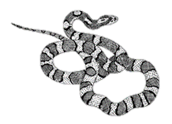

- Abiotic factor
- Acorn
- Animal tracks
- Bee
- Behavioral adaptation
- Biotic factor
- Bird’s nest
- Blooming flowers
- Butterfly
- Camouflage
- Cardinal
- Carnivore
- Caterpillar
- Clouds
- Consumer
- Decomposer
- Erosion
- Fish
- Flower
- Flying insect
- Food chain
- Fruit
- Herbivore
- Ladybug
- Mineral
- Omnivore
- Physical adaptation
- Pollen
- Producer
- Puddles
- Roots
- Scavenger
- Seedling
- Snake
- Squirrel
- Weathering
- Worm
- 3 different leaves
- Bonus points: pick up and throw away a piece of trash!

Illustrations by Cindie Brunner.
Header photo by Lauren Greene at South Mountains State Park on August 6, 2019.
Developed for the Schools in Parks Teacher Collaborative by the Center for Public Engagement with Science
in the UNC Institute for the Environment, in partnership with North Carolina State Parks.

